1. Landslide simulation based on discrete element

Code Operating environment: software PFC5.0

According to the discrete element program in 《Discrete element simulation of landslide and data extraction》, landslide simulation is carried out and landslide data is extracted (The results are shown in Figure 1).

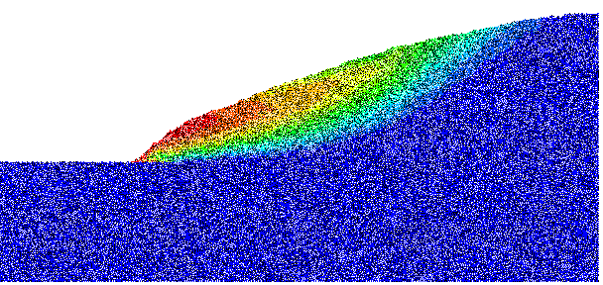

Figure 1 Landslide displacement cloud image

1. Classification of the slide mass

Code Operating environment: Matlab 2016b or above

You need to download《[Sample_1_after_landslide.xlsx](https://github.com/tangyid/dragonsleep/blob/main/Sample_1_after_landslide.xlsx)》, and then modify the data read path in 《[Sample_1_after_landslide.xlsx](https://github.com/tangyid/dragonsleep/blob/main/Sample_1_after_landslide.xlsx)》(Figure 2), and the program can be used normally, the output is shown in Figure 3.

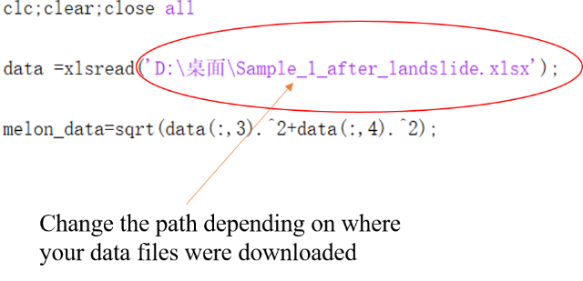

Figure 2 Change the data path based on your download

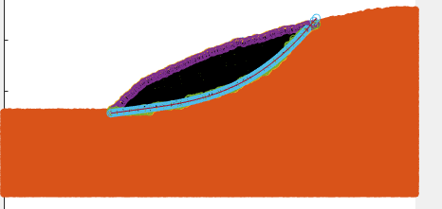

Figure 3 Classification of slide mass and fitting results of slip surface